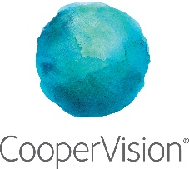

CooperVision Plastic Neutral Contact Lenses – Suggested Social Media Assets

Many of your patients are passionate about sustainability and protecting our planet. You have an opportunity to show that you share those values and to increase their loyalty to your practice by talking to them about CooperVision’s range¹ of plastic neutral contact lenses.²
The below suggested social media posts are designed to help you connect with your patients via your social media channels and create awareness of CooperVision’s Plastic Neutral contact lenses. The images contained are strictly licenced for limited use in social media platforms only. Right click on each image to save, then copy and paste the suggested text. If you have any queries regarding image use, please email hello@au.coopervision.com
Suggested Post Copy | Reference | Suggested Image
93% of wearers would choose the contact lens brand that they believe is more environmentally friendly.*¹ Ask us about plastic neutral contact lenses today. | * When choosing between two daily disposable contact lens brands that are comparable 1CooperVision data on file, 2021. Plastic Neutrality Survey 302 consumers aged 16-65 years, Decision Analyst October 2021 in Australia  CooperVision soft daily disposable contact lenses for vision correction. This product may not be right for you, refer to your optometrist for advice. Always read the label and follow the instructions for use | 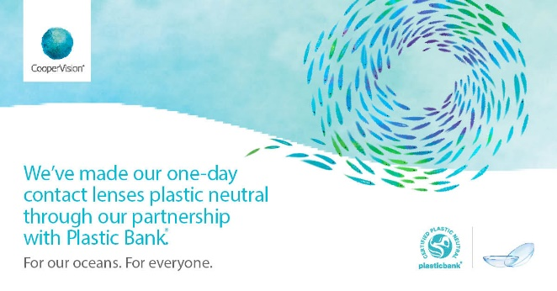
CooperVision® 1 day contact lenses are now plastic neutral*. Ask us for more information | *Plastic neutrality is established by purchasing credits from Plastic Bank. A credit represents the collection and conversion of one kilogram of plastic that may reach or be destined for waterways. CooperVision purchases credits equal to the weight of plastic in all CooperVision® 1 day orders in a specified time period. Plastic is determined by the weight of plastic in the blister, the lens, and the secondary package, including laminates, adhesives, and auxiliary inputs (e.g. ink)  CooperVision soft daily disposable contact lenses for vision correction. This product may not be right for you, refer to your optometrist for advice. Always read the label and follow the instructions for use (https://coopervision.net.au/patientinstruction) | 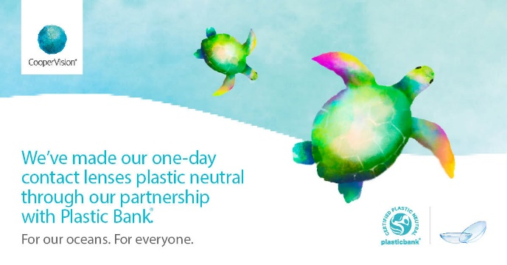
CooperVision® is partnering with Plastic Bank® to reduce ocean-bound plastic¹ and make their range of 1 day contact lenses the first to be plastic neutral.*² Ask us about plastic neutral contact lenses today. | 1CooperVision data on file, 2021, 2020-2020 Plastic Bank Contract Agreement.  * Range defined as all 1 day brands and segments: sphere, toric and multifocal.  2 Plastic neutrality is established by purchasing credits from Plastic Bank. A credit represents the collection and conversion of one kilogram of plastic that may reach or be destined for waterways. CooperVision purchases credits equal to the weight of plastic in all CooperVision® 1 day orders in a specified time period. Plastic is determined by the weight of plastic in the blister, the lens, and the secondary package, including laminates, adhesives, and auxiliary inputs (e.g. ink)  CooperVision soft daily disposable contact lenses for vision correction. This product may not be right for you, refer to your optometrist for advice. Always read the label and follow the instructions for use (https://coopervision.net.au/patientinstruction) | 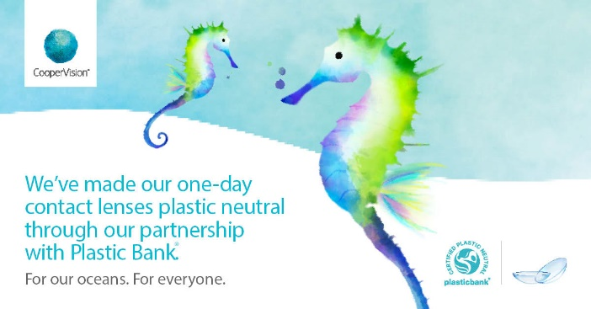
Ask us about plastic neutral contact lenses from CooperVision®.* www.coopervision.net.au/plasticneutral | *Plastic neutrality is established by purchasing credits from Plastic Bank. A credit represents the collection and conversion of one kilogram of plastic that may reach or be destined for waterways. CooperVision purchases credits equal to the weight of plastic in all CooperVision® 1 day orders in a specified time period. Plastic is determined by the weight of plastic in the blister, the lens, and the secondary package, including laminates, adhesives, and auxiliary inputs (e.g. ink)  CooperVision soft daily disposable contact lenses for vision correction. This product may not be right for you, refer to your optometrist for advice. Always read the label and follow the instructions for use (https://coopervision.net.au/patientinstruction) | 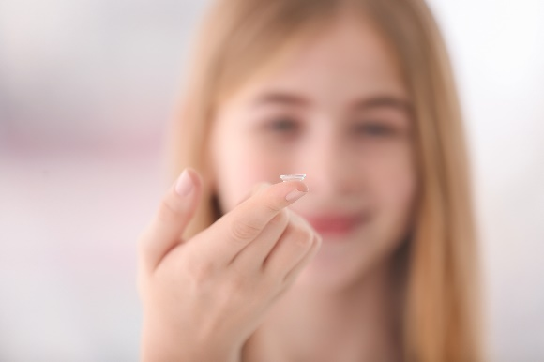
Ask us about plastic neutral 1 day contact lenses from CooperVision.* www.coopervision.net.au/plasticneutral | *Plastic neutrality is established by purchasing credits from Plastic Bank. A credit represents the collection and conversion of one kilogram of plastic that may reach or be destined for waterways. CooperVision purchases credits equal to the weight of plastic in all CooperVision® 1 day orders in a specified time period. Plastic is determined by the weight of plastic in the blister, the lens, and the secondary package, including laminates, adhesives, and auxiliary inputs (e.g. ink)  CooperVision soft daily disposable contact lenses for vision correction. This product may not be right for you, refer to your optometrist for advice. Always read the label and follow the instructions for use (https://coopervision.net.au/patientinstruction) | 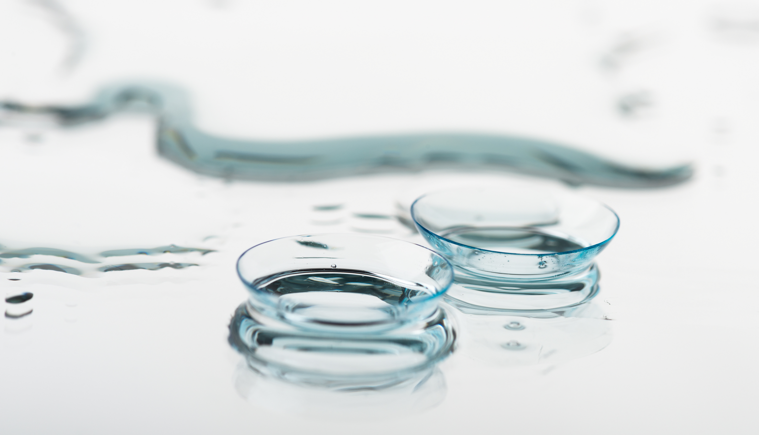
93% of contact lens wearers would choose the contact lens brand that they believe is more environmentally friendly.*¹ Ask us about plastic neutral contact lenses today. | * When choosing between two daily disposable contact lens brands that are comparable  1 CooperVision data on file, 2021. Plastic Neutrality Survey 302 consumers aged 16-65 years, Decision Analyst October 2021 in Australia  CooperVision soft daily disposable contact lenses for vision correction. This product may not be right for you, refer to your optometrist for advice. Always read the label and follow the instructions for use (https://coopervision.net.au/patientinstruction)
94% of contact lens wearers agree that keeping plastic out of our oceans is important¹—and so do we! Ask us about plastic neutral contact lenses at your next appointment, from CooperVision, the first and only contact lens manufacturer providing a full range* of plastic neutral lenses.² | 1 CooperVision data on file, 2021. Plastic Neutrality Survey 302 consumers aged 16-65 years, Decision Analyst October 2021 in Australia  2 CooperVision data on file, 2021, 2020-2020 Plastic Bank Contract Agreement.  *Range defined as all 1 day brands and segments: sphere, toric and multifocal.  CooperVision soft daily disposable contact lenses for vision correction. This product may not be right for you, refer to your optometrist for advice. Always read the label and follow the instructions for use (https://coopervision.net.au/patientinstruction) | 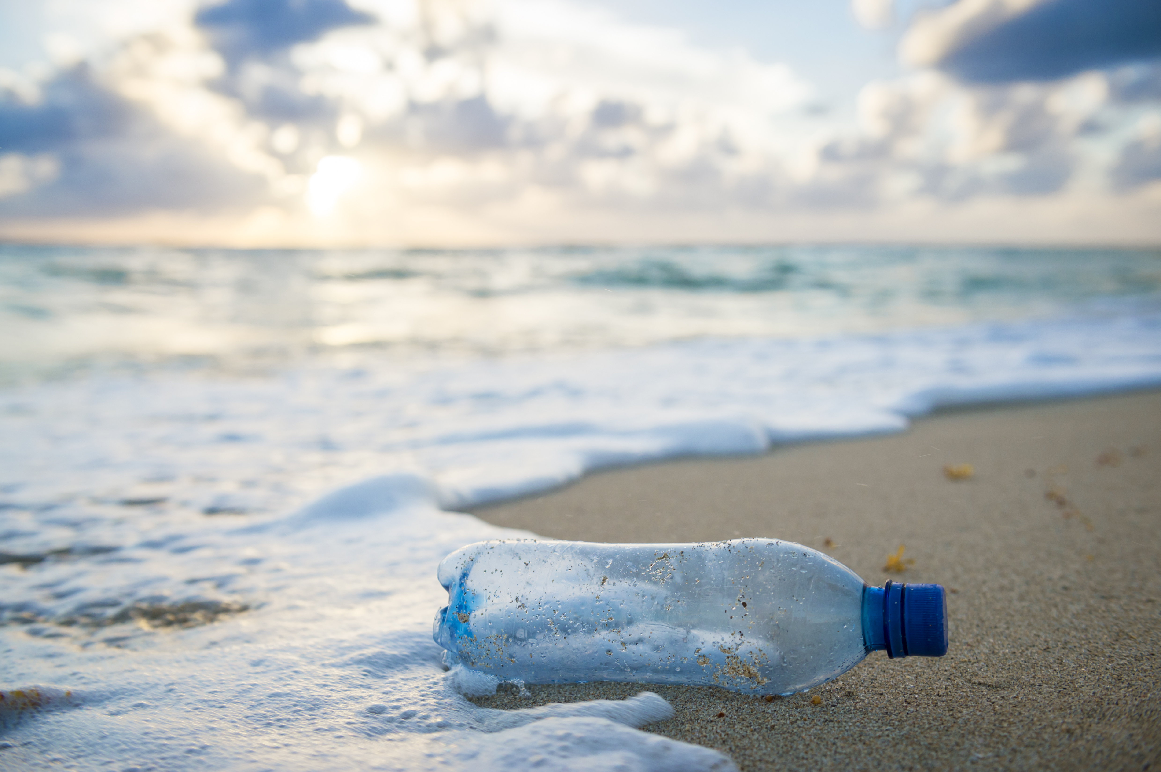
If contact lenses could be environmentally friendly, would you try them? You’re not alone. 93% of wearers would choose the brand that they believe is more environmentally friendly* ¹. Ask us about plastic neutral contact lenses today. | *When choosing between two daily disposable contact lens brands that are comparable.  1 CooperVision data on file, 2021. Plastic Neutrality Survey 302 consumers aged 16-65 years, Decision Analyst October 2021 in Australia  CooperVision soft daily disposable contact lenses for vision correction. This product may not be right for you, refer to your optometrist for advice. Always read the label and follow the instructions for use (https://coopervision.net.au/patientinstruction)
CooperVision® 1 day contact lenses are now plastic neutral.* Call us for an appointment today [INSERT PRACTICE PH NUMBER] | *Plastic neutrality is established by purchasing credits from Plastic Bank. A credit represents the collection and conversion of one kilogram of plastic that may reach or be destined for waterways. CooperVision purchases credits equal to the weight of plastic in all CooperVision® 1 day orders in a specified time period. Plastic is determined by the weight of plastic in the blister, the lens, and the secondary package, including laminates, adhesives, and auxiliary inputs (e.g. ink)  CooperVision soft daily disposable contact lenses for vision correction. This product may not be right for you, refer to your optometrist for advice. Always read the label and follow the instructions for use (https://coopervision.net.au/patientinstruction) | 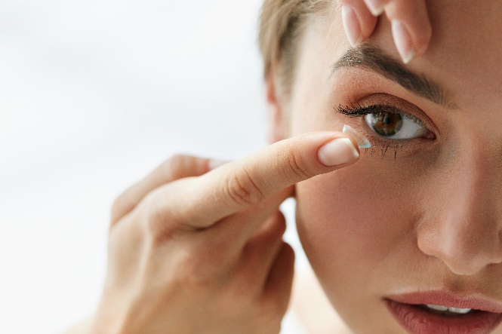
Sustainability is a BIG deal. 94% of Australian contact lens wearers agree keeping plastic out of oceans is important to them¹. Ask us about plastic neutral contact lenses today. | 1 CooperVision data on file, 2021. Plastic Neutrality Survey 302 consumers aged 16-65 years, Decision Analyst October 2021 in Australia  CooperVision soft daily disposable contact lenses for vision correction. This product may not be right for you, refer to your optometrist for advice. Always read the label and follow the instructions for use (https://coopervision.net.au/patientinstruction)
CooperVision® is partnering with Plastic Bank to reduce ocean-bound plastic¹ and make their range of 1 day contact lenses the first to be plastic neutral.*² Ask us about plastic neutral contact lenses today. | 1CooperVision data on file, 2021, 2020-2020 Plastic Bank Contract Agreement.  * Range defined as all 1 day brands and segments: sphere, toric and multifocal.  2 Plastic neutrality is established by purchasing credits from Plastic Bank. A credit represents the collection and conversion of one kilogram of plastic that may reach or be destined for waterways. CooperVision purchases credits equal to the weight of plastic in all CooperVision® 1 day orders in a specified time period. Plastic is determined by the weight of plastic in the blister, the lens, and the secondary package, including laminates, adhesives, and auxiliary inputs (e.g. ink)  CooperVision soft daily disposable contact lenses for vision correction. This product may not be right for you, refer to your optometrist for advice. Always read the label and follow the instructions for use (https://coopervision.net.au/patientinstruction) | 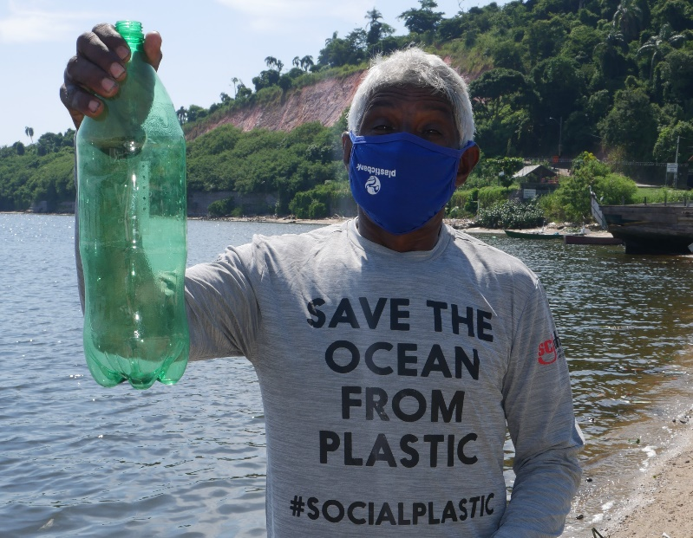

1. Range defined as all 1 day brands and segments: sphere, toric and multifocal. One-day contact lenses are defined as orders for those products and includes product sold and distributed by CooperVision in Australia and New Zealand.
2. Plastic neutrality is established by purchasing credits from Plastic Bank. A credit represents the collection and conversion of one kilogram of plastic that may reach or be destined for waterways. CooperVision purchases credits equal to the weight of plastic in our one-day contact lens orders in a specified time period. One-day contact lens plastic is determined by the weight of plastic in the blister, the lens and the secondary (outer carton) package, including laminates, adhesives, and auxiliary inputs (e.g. ink).

